***Introduction to Computer Hardware***

* Physical identification of major components of a computer system such:
* **Mother board**

The motherboard serves as a single platform to connect all of the parts of a computer together. It connects the CPU, memory, hard drives, optical drives, video card, sound card, and other ports and expansion cards directly or via cables. It can be considered as the backbone of a computer.

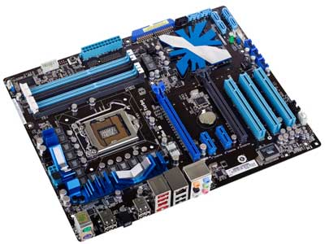

Features of Motherboard

A motherboard comes with following features −

* Motherboard varies greatly in supporting various types of components.
* Motherboard supports a single type of CPU and few types of memories.
* Video cards, hard disks, sound cards have to be compatible with the motherboard to function properly.
* Motherboards, cases, and power supplies must be compatible to work properly together.

Popular Manufacturers

Following are the popular manufacturers of the motherboard.

* Intel
* ASUS
* AOpen
* ABIT
* Biostar
* Gigabyte
* MSI

Description of Motherboard

The motherboard is mounted inside the case and is securely attached via small screws through pre-drilled holes. Motherboard contains ports to connect all of the internal components. It provides a single socket for CPU, whereas for memory, normally one or more slots are available. Motherboards provide ports to attach the floppy drive, hard drive, and optical drives via ribbon cables. Motherboard carries fans and a special port designed for power supply.

There is a peripheral card slot in front of the motherboard using which video cards, sound cards, and other expansion cards can be connected to the motherboard.

On the left side, motherboards carry a number of ports to connect the monitor, printer, mouse, keyboard, speaker, and network cables. Motherboards also provide USB ports, which allow compatible devices to be connected in plug-in/plug-out fashion. For example, pen drive, digital cameras, etc.

* **RAM modules**

Memory modules are computer chips used to add memory to a computer.

There are two basic distinctions of memory. One is volatile memory where the data is lost as soon as power is removed, and one is non-volatile that can store the data without power. Random access memory (RAM) is used as read-write memory, which the processor can use as a scratch pad and modify rapidly. It utilizes silicon transistors and capacitors to store data but is done so in a grid-like configuration with a transistor-capacitor pair at each intersection of the grid. The advantage of the grid architecture is that it allows any specific bit of information to be read and written at any time. Any point on the grid can be accessed by interrogating the two lines, which will read or write the spot at which they intersect. This type of volatile memory is very fast but the downfall is that the capacitors lose their charge over time so the data must constantly be refreshed. This constant refreshing aspect of the memory is called dynamic RAM or DRAM.

By contrast, static random access memory (SRAM) does not need to be refreshed. Because of this, SRAM is faster because it doesn’t require the time necessary to refresh each bit. SRAM is also more expensive and not used as often. Different types of SRAM may lose the memory after power is removed but some do not.

Non-volatile RAM memory, or NVRAM, is a class of memory that also has a grid architecture, but the data is retained even after the power is removed. Flash memory is an example of a type of NVRAM that utilizes a special type of metal oxide semiconductor field effect transistor (MOSFET) to store data. Other types of NVRAM are ferroelectric RAM (FeRAM) and magnetoresistive ram (MRAM).

Read only memory (ROM) is memory that contains preset instructions and data, often for controlling physical devices like disk drives associated with the PC. ROM is non-volatile so it does not lose what is stored without power. While the name suggests that it is read-only and certain types are, more often it is read-only during normal operation but can be written under the special circumstances. ROM also covers a wide array of memory types.

Programmable read-only memory (PROM) is a type of ROM that is typically programmed once and can’t be changed after that. This type of memory is used in things like firmware and RFID chips. It is often used in hardware that has a dedicated purpose that will not change.EPROM memory is similar to PROM with one key difference. It can be erased and reprogrammed although this is not expected to happen often. The memory chips have an optical window on them, which must be exposed to UV light that will erase the memory and allow them to be reprogrammed. With this method, the memory must be completely erased before any new information is written.

Since the UV light method is somewhat inconvenient, electrically erasable programmable read-only memory (EEPROM) was developed. Erasing and programming are typically done with a voltage higher than normal operation.

**Types**

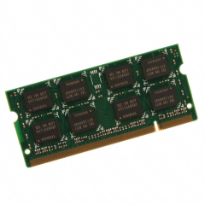Choices for memory type include:

* RAM (random access memory)
* DRAM (direct random access memory)
* FPM RAM (fast page mode RAM)
* EDO RAM (extended data output RAM)
* BEDO RAM (burst extended data output RAM)
* SDRAM (synchronous DRAM)
* SRAM (static random access memory)
* L2 Cache (level 2 cache)
* Async RAM (asynchronous RAM)
* Sync RAM (synchronous RAM)
* PB SRAM (pipelined burst SRAM)
* VRAM (video RAM)
* WRAM (window RAM)
* SGRAM (synchronous graphics RAM)
* ROM (read only memory)
* PROM (programmable read only memory)
* EPROM (erasable programmable read only memory)
* EEPROM (electronically erasable programmable read only memory)
* Flash

**Specifications**

The form factor of any memory module describes its size and pin configuration. Most computer systems have memory sockets that can accept only one form factor. Choices for form factor include:

* SIMM — Single in-line memory module (SIMM) offers a data path of 32 bits. Because Pentium® memory modules are designed to handle a much wider data path than that, SIMMs must be used in pairs on Pentium motherboards (they can be used singly on boards based on 486 or slower processors).
* DIMM — Dual in line memory module (DIMM), which are of more recent origin, offer a 64-bit path, which makes them more suitable for use with the Pentium and other more recent processors. One DIMM will handle the work of two SIMMs and thus can be used singly on a Pentium motherboard. DIMMs are more economical in the long run, because they can be added one at a time to a system.

**Features**

* Capacity is the amount of data that can be transmitted over a specific period of time.
* Clock speed is the raw MHz that the CPU (Central Processor Unit) operates at. For example, an AMD Athlon 1 GHz has an operating clock speed of 1,000 MHz; this is the processor's clock speed.
* The cycle time is the length of time it takes to transmit data expressed in terms of the minimum amount of time required for a memory to complete a cycle such as read, write, read/write, or read/modify/write.
* Error checking and correction features of memory cards include parity, error checking parity, and nonparity. As data moves through a computer (e.g., from the CPU to the main memory), the possibility of errors can occur, particularly in older machines. Parity error detection was developed to notify the user of any data errors. By adding a single bit to each byte of data, this bit is responsible for checking the integrity of the other 8 bits while the byte is moved or stored. Once a single-bit error is detected, the user receives an error notification; however, parity checking only notifies, and does not correct a failed data bit. If your SIMM module has 3, 6, 9, 12, 18, or 36 chips then it is more than likely parity. Error Checking and Correction (ECC) modules have an extra chip that detects if the data was correctly read or written by the memory module. If the data wasn't properly written, the extra chip will correct it in many cases (depending on what type of error). Non-parity (also called non-ECC) modules do not have an error-detecting feature.

**Applications**

Memory is used in lots of digital electronic devices from smart phones and watches to electronic toothbrushes and radios. Just about any electric device that needs to store information uses some form of memory. For a monitor or TV, this storage may be for the internal software that makes the device run, or as temporary storage for a processor. Many modern appliances such as refrigerators, thermostats, air conditioners, and automobiles use memory, as well as:

* Personal computing
* Motherboards and RAID cards
* Digital electronics
* Servers and networking
* Printers and imaging
* **Daughter cards**

A daughter card or [**daughterboard**](https://www.easytechjunkie.com/what-is-a-daughterboard.htm) is a type of [**circuit board**](https://www.easytechjunkie.com/what-is-a-circuit-board.htm) that gets added to an existing one. Its name is appropriate for its use, since it is connected to a “[**motherboard**](https://www.easytechjunkie.com/what-is-a-motherboard.htm)” or “main board.” The motherboard is the primary circuit board for a device. It is usually in the device as it is shipped from the factory. A daughter rcard may be added later.

Some daughter card designs are made so that engineers can add functionality to a device without requiring a lot more room inside its housing. These kinds of items are often called riser boards or risers. Some might also call them “mezzanine boards.”

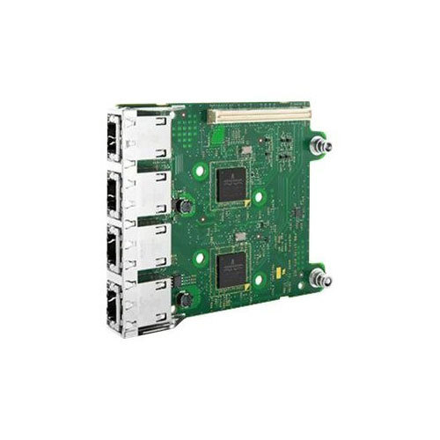

Daughter cards are different from some other types of additional circuit boards that tech enthusiasts call “expansion cards.” In expansion cards, the circuit board is often plugged in through a gap in the housing of a computer or device. These expansion boards help to give a device more functionality, often for additional sound play or for better visuals on a high-tech monitor or screen.

In contrast to the way expansion boards are used, a daughter card can be a more fundamental enhancement for a device. Adding a daughter card often requires getting into the guts of a device. That’s why some users might hire a professional to install it. Companies that make an electronic device might offer a daughter card as part of an essential upgrade that allows the product to be used in more various ways.

With the rise of connective USB ports and other technology, it has become less necessary to upgrade devices with daughter cards or daughter boards. A lot of advanced use can be built into a wireless connection and “outsourced” to a remote server, rather than adding it physically into a desktop or laptop computer. However, some types of equipment might still get these kinds of additions as provided by the manufacturer. Computer and electronics makers choose the best ways of offering upgrades that they feel will match the needs and desires of their customer base. Since not a lot of laptop or computer users want to wrestle a daughter card into an existing circuit board design, companies that sell to a consumer market will probably choose alternatives, or offer professional installation as a free service if they are offering a daughter card as a way to upgrade a device.

* **Bus slots**

Alternatively known as a **bus slot** or **expansion port**, an **expansion slot** is a connection or port inside a [computer](https://www.computerhope.com/jargon/c/computer.htm) on the [motherboard](https://www.computerhope.com/jargon/m/mothboar.htm) or [riser card](https://www.computerhope.com/jargon/r/risecard.htm). It provides an installation point for a hardware expansion card to be connected. For example, if you wanted to install a new video card in the computer, you'd purchase a video expansion card and install that card into the compatible expansion slot.

## Computer expansion slots

Below is a listing of expansion slots commonly found in a computer and the devices associated with those slots. Clicking any of the links below provide you with additional details.

* [**AGP**](https://www.computerhope.com/jargon/a/agp.htm) - [Video card](https://www.computerhope.com/jargon/v/video-card.htm).
* [**AMR**](https://www.computerhope.com/jargon/a/amr.htm) - [Modem](https://www.computerhope.com/jargon/m/modem.htm), [sound card](https://www.computerhope.com/jargon/s/souncard.htm).
* [**CNR**](https://www.computerhope.com/jargon/c/cnr.htm) - Modem, [network card](https://www.computerhope.com/jargon/n/nic.htm), sound card.
* [**EISA**](https://www.computerhope.com/jargon/e/eisa.htm) - [SCSI](https://www.computerhope.com/jargon/s/scsi.htm), network card, video card.
* [**ISA**](https://www.computerhope.com/jargon/i/isa.htm) - Network card, sound card, video card.
* [**PCI**](https://www.computerhope.com/jargon/p/pci.htm) - Network card, SCSI, sound card, video card.
* [**PCI Express**](https://www.computerhope.com/jargon/p/pciexpre.htm) - Video card, modem, sound card, network card.
* [**VESA**](https://www.computerhope.com/jargon/v/vesa.htm) - Video card.

Many of the expansion card slots above are obsolete. You're most likely only going to encounter AGP, PCI, and PCI Express when working with computers today. The picture below is an example of what expansion slots may look like on a motherboard. In this picture, there are three different types of expansion slots: PCI Express, PCI, and AGP

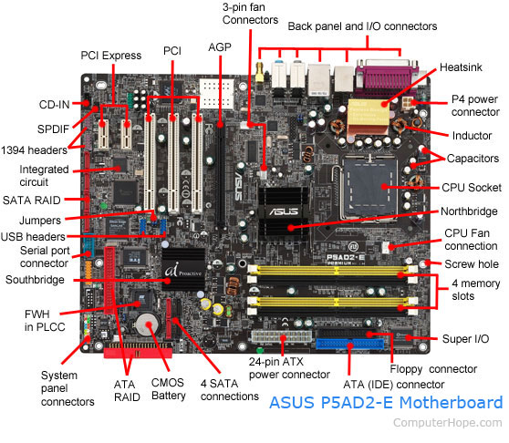

## How many expansion slots does my computer have?

Every computer motherboard is different, to determine how many expansion slots are on your computer motherboard identify the manufacturer and model of the motherboard. Once you've identified the model of motherboard, you can find complete information about the motherboard in its manual.

Adding additional expansion slots for older motherboards could be accomplished using a [riser board](https://www.computerhope.com/jargon/r/risecard.htm), which would add several ISA or PCI slots. Today, riser boards are rarely used with motherboards, as there is limited need for additional expansion slots with modern motherboards.

## What type of expansion slots are on my motherboard?

As mentioned above, every motherboard model is unique, so to determine the type of expansion slots on the motherboard, consult the board's [specifications](https://www.computerhope.com/jargon/s/specific.htm) and owner's manual. You can also open the computer [case](https://www.computerhope.com/jargon/c/chassis.htm) and visually examine the motherboard.

## Why do computers have expansion slots?

Computers have expansion slots to give the user the ability to add new devices to their computer. For example, a computer gamer may upgrade their [video card](https://www.computerhope.com/jargon/v/video-card.htm) to get better performance in their games. An expansion slot allows them to remove the old video card and add a new video card without replacing the motherboard.

## What is the most common expansion slot today?

Today, the most commonly used expansion slot used and found on computer motherboards is the [PCI Express](https://www.computerhope.com/jargon/p/pciexpre.htm) expansion slot.

## Does a laptop have an expansion slot?

Laptops do not have expansion slots like a desktop computer. However, some laptops do have [PC Cards](https://www.computerhope.com/jargon/p/pccard.htm) that can be inserted into the side of the laptop. They may also have a [Card bus](https://www.computerhope.com/jargon/c/cardbus.htm) slot for an [Express Card](https://www.computerhope.com/jargon/e/expressc.htm) to be added.

* **SMPS**

What Does Switched-Mode Power Supply (SMPS) Mean?

A switched-mode power supply (SMPS) is an electronic circuit that converts power using switching devices that are turned on and off at high frequencies, and storage components such as inductors or capacitors to supply power when the switching device is in its non-conduction state.

Switching power supplies have high efficiency and are widely used in a variety of electronic equipment, including computers and other sensitive equipment requiring stable and efficient power supply.

A switched-mode power supply is also known as a switch-mode power supply or switching-mode power supply.

Techopedia Explains Switched-Mode Power Supply (SMPS)

Switched-mode power supplies are classified according to the type of input and output voltages. The four major categories are:

* AC to DC
* DC to DC
* DC to AC
* AC to AC

A basic isolated AC to DC switched-mode power supply consists of:

* Input rectifier and filter
* Inverter consisting of switching devices such as MOSFETs
* Transformer
* Output rectifier and filter
* Feedback and control circuit

The input DC supply from a rectifier or battery is fed to the inverter where it is turned on and off at high frequencies of between 20 KHz and 200 KHz by the switching MOSFET or power transistors. The high-frequency voltage pulses from the inverter are fed to the transformer primary winding, and the secondary AC output is rectified and smoothed to produce the required DC voltages. A feedback circuit monitors the output voltage and instructs the control circuit to adjust the duty cycle to maintain the output at the desired level.

There are different circuit configurations known as topologies, each having unique characteristics, advantages and modes of operation, which determines how the input power is transferred to the output.

Most of the commonly used topologies such as flyback, push-pull, half bridge and full bridge, consist of a transformer to provide isolation, voltage scaling, and multiple output voltages. The non-isolated configurations do not have a transformer and the power conversion is provided by the inductive energy transfer.

Advantages of switched-mode power supplies:

* Higher efficiency of 68% to 90%
* Regulated and reliable outputs regardless of variations in input supply voltage
* Small size and lighter
* Flexible technology
* High power density

Disadvantages:

* Generates electromagnetic interference
* Complex circuit design
* Expensive compared to linear supplies

Switched-mode power supplies are used to power a wide variety of equipment such as computers, sensitive electronics, battery-operated devices and other equipment requiring high efficiency.

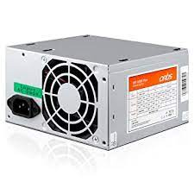

* **Internal storage devices**

Some storage devices are classed as 'internal' which means they are inside the computer case. Most computers have some form of internal storage. The most common type of internal storage is the hard disk.

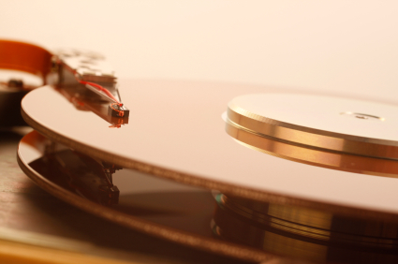

At the most basic level, internal storage is needed to hold the operating system so that the computer is able to access the input and output devices. It will also be used to store the applications software that you use and more than likely, the original copies of your data files. Internal storage allows the data and applications to be loaded very rapidly into memory, ready for use. The data can be accessed much faster than data which is stored on an external storage device. This is because internal storage devices are connected directly to the motherboard and its data bus whereas external devices are connected through a hardware interface such as USB, which means they are considerably slower to access.

Internal storage also means that if the computer is moved around, it will still retain its most commonly used data. The main disadvantage of internal storage is that when the hard disk fails (and it will), all the data and applications may be lost. This can be avoided to some extent by using more than one hard disk within the machine. Each hard disk has a copy of all the data, so if one fails the other can carry on. This is called a RAID array. An alternative is to use external drives for backup

* © www.teach-ict.com
* **Interfacing ports**

A port is a physical docking point using which an external device can be connected to the computer. It can also be programmatic docking point through which information flows from a program to the computer or over the Internet.

## Characteristics of Ports

A port has the following characteristics −

* External devices are connected to a computer using cables and ports.
* Ports are slots on the motherboard into which a cable of external device is plugged in.
* Examples of external devices attached via ports are the mouse, keyboard, monitor, microphone, speakers, etc.

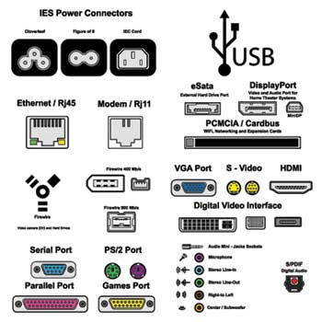

Let us now discuss a few important types of ports −

Serial Port

* Used for external modems and older computer mouse
* Two versions: 9 pin, 25 pin model
* Data travels at 115 kilobits per second

Parallel Port

* Used for scanners and printers
* Also called printer port
* 25 pin model
* IEEE 1284-compliant Centronics port

PS/2 Port

* Used for old computer keyboard and mouse
* Also called mouse port
* Most of the old computers provide two PS/2 port, each for the mouse and keyboard
* IEEE 1284-compliant Centronics port

Universal Serial Bus (or USB) Port

* It can connect all kinds of external USB devices such as external hard disk, printer, scanner, mouse, keyboard, etc.
* It was introduced in 1997.
* Most of the computers provide two USB ports as minimum.
* Data travels at 12 megabits per seconds.
* USB compliant devices can get power from a USB port.

VGA Port

* Connects monitor to a computer's video card.
* It has 15 holes.
* Similar to the serial port connector. However, serial port connector has pins, VGA port has holes.

Power Connector

* Three-pronged plug.
* Connects to the computer's power cable that plugs into a power bar or wall socket.

Firewire Port

* Transfers large amount of data at very fast speed.
* Connects camcorders and video equipment to the computer.
* Data travels at 400 to 800 megabits per seconds.
* Invented by Apple.
* It has three variants: 4-Pin FireWire 400 connector, 6-Pin FireWire 400 connector, and 9-Pin FireWire 800 connector.

Modem Port

* Connects a PC's modem to the telephone network.

Ethernet Port

* Connects to a network and high speed Internet.
* Connects the network cable to a computer.
* This port resides on an Ethernet Card.
* Data travels at 10 megabits to 1000 megabits per seconds depending upon the network bandwidth.

Game Port

* Connect a joystick to a PC
* Now replaced by USB

Digital Video Interface, DVI port

* Connects Flat panel LCD monitor to the computer's high-end video graphic cards.
* Very popular among video card manufacturers.

Sockets

* Sockets connect the microphone and speakers to the sound card of the computer.
* Specifications for desktop and server class computers
* Here is a sample desktop computer specification if you are searching for a good desktop computer to buy. I have listed the most component features you should check when you buy desktop computer.
* Actually, the intended usage of a computer should be your first step to answer. Why are you going to buy? What are you going to do with it? I say this because you don’t have to buy a high-end pc for tasks such as word processing, spreadsheet, web browsing or e-mail.
* If you do have enough budgets, go for it. For the future it will serve you well for graphical and design works too.
* This is a typical desktop computer specification, this doesn’t mean you should buy this computer. It is just a guide to help you.

|  |
| --- |
|  |
| **Manufacture**r | Cabinet type: | Dell, Compaq, HP or other good brands |
|  | Operating system: | Windows XP, Windows Vista, Windows 7 |
| **Processor** | Manufacturer: | Intel or AMD Processor |
| Type: | Intel Core Duo Processor |
| Speed: | 2.0GHZ |
| Bus Speed: | 1000MHZ |
| **Motherboard** | Form Factor: | ATX, Micro-ATX |
| Chipset: | Intel 945G Express |
| No of PCI Slots: | 4 |
| Peripheral Connectors (Front): | USB 2.0 (2), headphone/speaker out |
| Peripheral Connectors (Back): | USB 2.0 (5), VGA out, Ethernet (Rj-45), Stereo Line-in, Microphone, Speaker/Line out, Serial and Parallel ports |
| **Storage Drives** | Hard Drive Capacity: | 200GB |
| Hard Drive Interface: | SATA, 7200RPM |
| **Memory** | Memory Type: | DDR2 SDRAM |
| Installed memory: | 1GB |
| Upgradable: | Up to 4GB |
| **CD/DVD Drives** | Optical Drive Type: | DVD-RW |
| CD Read Speed: | 52x and so on |
| DVD Read Speed: | 8x, 16x and so on |
| **Monitor** | (Display) Screen type: | LCD or CRT Screen |
| Resolution: | 1280 X 1024 or more |
| Refresh Rate: | 60HZ or more |
| Diagonal size: | 17” or more |
| **Video Card** | Type: | Intel Graphics Media Accelerator |
| Interface Type: | Integrated |
| Video card memory: | 256MB |
| **Sound Card** | Type: | Integrated Digital Audio |
| Interface Type: | Integrated |
| **Keyboard** |  | USB Enhanced QWERTY keyboard |
| **Mouse** | USB Optical 2-Button Scroll mouse | |
| **Speakers** | Built in Speaker, Integrated sound speaker | |
| **Power Supply** |  |  |

This desktop computer specification covers the most important parts you should carefully look when you buy a new system.  
There are a lot of desktop computer brands, however, you may choose from the known manufacturers who have good support.

#### Server-Class Machine Requirements

Server-class machine requirements pertain to the following TT products:

* TT Gateway
* Autospreader® SE
* Algo SE
* Synthetic SE
* FIX Adapter
* FMDS
* Price Proxy
* Historical Fill Server (HFS)
* TT WAN Router
* X_TRADER® Remote Host

|  |  |
| --- | --- |
| **Hardware** | **Requirement** |
| Operating System | Windows Server 2012: requires TT Gateway 7.17.50 and higher.  Windows Server 2008 R2  **Note**: TT Gateways 7.15 and earlier require Windows Server 2003. |
| Processor and Memory | Four cores (eight cores or more is preferred) with a minimum of 4GB RAM |
| Network Card | * Two or more NICs with one pointed to the internal network and one or more pointed to the exchange * Match the speed and duplex settings of the switch port and NIC to maximize speed and avoid duplex mismatches   **Note**: Due to driver and firmware limitations, TT does not recommend using certain Ethernet cards in a production environment. Refer to [Server-Class Machine Optimizations](https://www.tradingtechnologies.com/help/tt-system-requirements/server-systems-overview/) for specific chipset and version recommendations. |
| Hard Drive | 30 GB or more of available space to accommodate TT software and log files |

* SQL Databases

|  |  |
| --- | --- |
| **Server or Product** | **Recommendation or Exception** |
| Algo SE | Algo SE requires at least Windows Server 2003 R2, 64-bit and at least 8 cores (e.g., two-quad core processors). |
| Autospreader SE | Autospreader SE 7.17 and higher requires Windows Server 2008 R2, 64-bit. Older versions require Windows Server 2003 R2, 32 or 64 bit.  All versions require at least 8 cores (e.g., two-quad core processors). |
| Synthetic SE | Synthetic SE 7.17 and higher requires Windows Server 2008 R2, 64-bit. Synthetic SE 7.3.X 64-bit also requires Windows Server 2008 R2, 64-bit.  All Synthetic SE 32-bit versions require Windows Server 2003 R2, 32 or 64 bit.  All versions require at least 8 cores (e.g., two-quad core processors). |
| FIX Adapter | FIX Adapter 7.8.x 64-bit and higher requires Windows Server 2003 R2, 64-bit or Windows Server 2008 R2, 64-bit.  FIX Adapter 7.8.x 32-bit and higher requires Windows Server 2003 R2, 32-bit or 64-bit, or Windows Server 2008 R2, 32-bit or 64-bit.  Pre-7.8.x FIX Adapters require Windows Server 2003 R2, 32-bit or 64-bit.  60GB or more of available space, per FIX Adapter instance and .Net Framework 2.0 or higher |
| FMDS | 300 GB or larger hard drive |
| TT User Setup Server | Requires at least two instances of the TT User Setup Server per trading environment |
| TTM | When TTM is deployed as a Remote Host, TT recommends Windows Server 2008 R2, SP1 64-bit for optimum performance and scalability |
| HFS | Hard drive capacity depends on the amount of data being saved, and how many markets are being traded, etc. 300 GB or larger hard drive is recommended. |

* Installation of common operating systems for desktop and server use

### Method1

### Installing Windows 10

**1**

**Create a Windows Installation Media.** If you order Windows 10 for a new PC build, they may send you an installation media. If you don't have a Windows installation media, you can make one. You'll need a computer with internet access and an 8 GB USB flash drive (16 GB recommended). You also need to know if the computer you want to install Windows 10 on has [32-bit or 64-bit architecture](https://www.wikihow.com/Check-if-Your-PC-Is-Running-the-32-Bit-or-64-Bit-Version-of-Windows). You will also need to purchase Windows to get a product key. This can be done before or after the installation. Use the following steps to create a Windows Installation Media:

* + Insert a USB drive with at least 8 GB of space into any computer with internet access. This will wipe any existing data on the USB drive, so be sure to back up any data you want to keep.
  + Go to <https://www.microsoft.com/en-us/software-download/windows10> in a web browser.
  + Click **Download Tool Now**.
  + Open the "MediaCreationTool.exe" file in your web browser or Downloads folder.
  + Click **Accept**.
  + Select "Create Installation Media (USB drive, DVD, ISO file) for another PC" and click **Next**.
  + Select your language, Windows edition, and PC architecture and click **Next**.
  + Select "USB flash drive" and click **Next**.
  + Select your USB drive and click **Next**.

**2**

[**Back up your files**](https://www.wikihow.com/Back-Up-Your-Files-in-Windows-10)**(optional).** If you already have a Windows installation on your computer, a new Windows installation may overwrite your files. Back up any data you want to keep before beginning a new Windows installation. You can back up your files to OneDrive, Google Drive, Dropbox, or an external hard drive or USB flash drive.

**3**

**Insert the Windows Installation Media in the computer you want to install Windows on.** You can insert the Windows Installation media into any free USB port.

**4**

**Boot the computer.** If the PC is already powered on, restart it using the normal restart procedures of the operating system that is installed on the PC. If it is not yet powered on, press the power button to boot it up.

**5**

**Enter the Boot menu.** Most newer computers have a boot menu you can enter while booting up. The way you enter it is different, depending on your motherboard. The most common way to enter the Boot menu is to press **F10**, **F11**, **F12**, **F2**, or **Esc** as the PC boots up. This Boot menu will display a list of drives you can boot from.[[1]](https://www.wikihow.com/Install-an-Operating-System-on-a-Brand-New-Computer#_note-1)

* + If you are using an older PC that does not have a Boot menu, you will need to [Enter the BIOS](https://www.wikihow.com/Enter-BIOS) while booting up. The buttons you press to enter the BIOS is different from one PC manufacturer to another. It will usually say what buttons you need to press while your computer boots up. You typically need to press **F1** **F2**, **F3**, **Esc** or **Delete** to enter the BIOS.[[2]](https://www.wikihow.com/Install-an-Operating-System-on-a-Brand-New-Computer#_note-2)You may need to be quick about it. You can also reboot your PC into the BIOS from inside the Windows Settings menu.

**6**

**Select the USB drive.** This is the drive that has the Windows Installation Media. This will boot the PC from the Windows Installation Media. Once the computer boots from the USB drive, press any key to start the Windows installation process.

* + If you are inside the BIOS settings. Locate the option that says "Boot", "Boot order", "Priorities" or something similar. Change the boot order so that your PC boots from the USB drive first. Then select the option to save and exit. This will reboot your PC from the USB drive.

**7**

**Select your language, time and currency, and keyboard input and click Next.** Use the drop-down menus to first select your language. Then select your country or region, and your keyboard input method. Then click **Next**.

**8**

**Click Install Now.** It's the button in the center of the screen.

**9**

**Enter your Windows product key and click Next.** If you've already purchased Windows, you can find your license key in your confirmation email. If you have not purchased Windows, click **I don't have a product key**. You'll need to purchase Windows and activate it later on.

**10**

**Select which edition of Windows you want to install and click Next.** If you've already purchased Windows, check which version of Windows you purchased and make sure you click the right version. If you have not yet purchased Windows, check which version you want to install. Different versions of Windows have a different price.

* + If you are not sure which version of Windows to install, Windows Home Edition is the most common version of Windows.

**11**

**Click the checkbox next to "I accept the license terms" and click Next.** You can read the license terms in the window in the center. Click next when you are ready to continue.

**12**

**Click Custom: Install Windows only or Upgrade: Install Windows and keep files, settings, and applications.** If your computer already has a Windows installation on it, click **Upgrade: Install Windows and keep files, settings, and applications**. If your computer does not have a Windows installation or you need to reinstall Windows, click **Custom: Install Windows only**.

**13**

**Select a drive or partition you want to install Windows on and click Delete.** If you have multiple hard drives or a hard drive with multiple partitions, select the partition you want to install Windows on and click **Delete**. Be aware that this will erase all data on the drive. Make sure you have backed up all data you want to keep before continuing. This will leave the drive with unallocated space.

**14**

**Select a drive with unallocated space and click Next.** This will start installing Windows on the drive you selected. The amount of time it takes will depend on the hardware of your computer.

**15**

**Remove the USB flash drive and restart your computer.** Once Windows is finished installing, your computer will restart automatically. Remove the USB flash drive so that it does not try to boot from the Flash drive again. The first time Windows boots up, you will need to go through the Setup process.